Jawahar navodaya vidyalaya, korlahalli

DIST-GADAG-582118

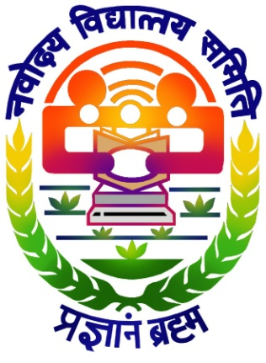

NATIONAL CHILDREN’S SCIENCE CONGRESS 2022-23

Theme: **Understanding Ecosystem for Health and Well-being**

Sub-Theme: **Fostering Health, Nutrition and Well-being**

**TITLE:**

Agricultural Methods of Cultivating Nutritional Food

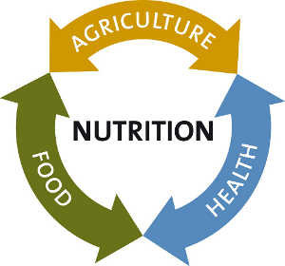

Contents

* Introduction
* Aim
* Objective
* Hypothesis
* Study
* Data Analysis
* Results
* Conclusion
* References

**TITLE:**

**“**Traditional Agricultural Methods and Organic food”

Introduction:

Nowadays, health is one of the important aspects that people are most concerned about. Health is directly related with our lifestyle. In our daily life, the food we eat, work done by us, climatic conditions, many such aspects affect our health.

Food we eat matters a lot, as it provides all the nutrients that are essential for survival. Food includes vegetables, fruits, cereals, pulses, meat, dairy products etc. Agriculture is the source of vegetables, fruits, cereals, pulses. All the agricultural methods or procedures also give an impact over health indirectly. So, we have to take a look over all the agricultural methods and see the advantages and disadvantages and the food cultivated.

Aim:

To find out the best agricultural practices to improve the quality of food.

Objective:

* To study difference between different types of food.
* To study what difference in cultivation makes the food different.
* To study the benefits of food over health.

Hypothesis:

Modern agricultural methods give a better outcome in short-run, but can prove to be a threat in the long-run.

Study:

Our ancestors, were unaware of the word ‘technology’. This technology is surely a gift which is supposed to ease our life in all the fields. In agricultural sector it has given has a number of tools and chemicals which will reduce labour stress and improve the production. But as we know our ancestors didn’t use these. They used all the machineries made up of wood, manures,composts for fertilizing land. So does modern methods and traditional methods make any changes.On comparing both the methods only fertilizers make a huge difference, as machineries are just for the maintenance and easing of the procedure.

As manures and composts which are made up of only organic substances is used in traditional farming, the cultivated food is said to be ***organic food.*** And, most of the modern fertilizers contain inorganic substances, the cultivated food is said to be ***inorganic food.***

***Organic Fertilisers:***

* Increase the organic matter content of soil and improve soil texture.
* Improve water retention and resistance to erosion.
* Improve saline water leaching.
* Declining sodicity.
* Reducing bulk density.
* Increased porosity and aeration.
* Examples: Manure, Compost, Rock Phosphate etc.

***Inorganic Fertilisers:***

* Allow growers to maximize their crop yield.
* Helps in short-time period.
* Alter the pH(acidification).
* Excessive use results in soil degradation, nitrogen leaching, reduction in soil organic matter.
* Contribute to groundwater pollution.
* Emission of greenhouse gases.

***By considering the above points, we can conclude that organic fertilizers are eco-friendly. But we will have to study the nutritional value of the cultivated food***

***Nutritional Value of Food:***

* A 2003 study found that organically grown berries and corn contained 58% more antioxidants and up to 52% higher amount of vitamin C than inorganic food. Higher antioxidant content helped protect cells from damage.
* One study reported that organic food was containing 48% lower levels of cadmium, which is an extremely toxic metal.
* Biochemists at Dumfries and Galloway Royal Infirmary and at the University of Strathclyde in Scotland compared the salicylic acid levels in different soups. Organic carrot, coriander soups contained 1040 nanograms of salicylic acid per gram compared with 20 nanograms in the average nonorganic soup.

Data Analysis:

The below chart shows the nutritional value of organic and inorganic food respectively:

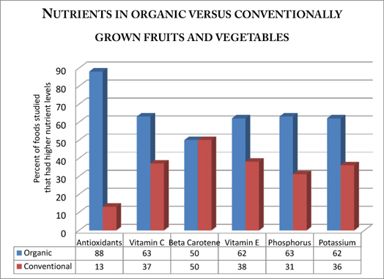

A Collaborative study from USDA and Montana State University found that Organic farming of wheat and grazing has the potential to reduce the net greenhouse gas emissions, thus, it can lower global warming.

Results:

* Organic food contains more essential nutrients, minerals, enzymes and micronutrients. They also contain a very low level of toxic substances.
* As Organic fertilisers such as manure, compost, etc., are used instead of chemical fertilizers, it helps to rebuild soil health and results in greater bio-diversity.
* Organic food is never irradiated. Irradiated food is exposed to an intense ionizing radiation, to kill bacteria and reduce micro-organisms, but this is likely to cause cancer.
* Choosing organic protects the streams, lakes and downstreams from toxic run off, that in produced by inorganic farming.

Conclusion:

All the above results hereby conclude that organic food is much more beneficial to us in many ways. It has a better nutritional value, lower levels of toxic substances. Organic fertilizers used in organic farming are having much more benefits such as maintains the soil health, improves soil texture, water retention, resistance to erosion and porosity and aeration.

References:

1. Lisa Watson, Medill Reports Chicago, Northwestern 2008 (Graph Chart)